Service Oriented Architecture (SOA)

A Service-Oriented Architecture or SOA is a design pattern which is designed to build distributed systems that deliver services to other applications through the protocol. It is only a concept and not limited to any programming language or platform.

What is Service?

A service is a well-defined, self-contained function that represents a unit of functionality. A service can exchange information from another service. It is not dependent on the state of another service. It uses a loosely coupled, message-based communication model to communicate with applications and other services.

Service Connections

The figure given below illustrates the service-oriented architecture. Service consumer sends a service request to the service provider, and the service provider sends the service response to the service consumer. The service connection is understandable to both the service consumer and service provider.

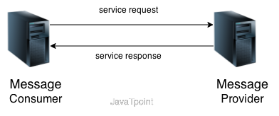

Service-Oriented Terminologies

Let's see some important service-oriented terminologies:

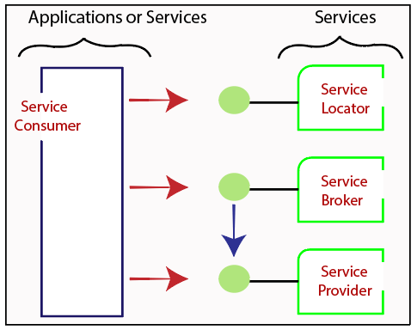

* **Services -** The services are the logical entities defined by one or more published interfaces.
* **Service provider -** It is a software entity that implements a service specification.
* **Service consumer -** It can be called as a requestor or client that calls a service provider. A service consumer can be another service or an end-user application.
* **Service locator -** It is a service provider that acts as a registry. It is responsible for examining service provider interfaces and service locations.
* **Service broker -** It is a service provider that pass service requests to one or more additional service providers.

Characteristics of SOA

The services have the following characteristics:

* They are loosely coupled.
* They support interoperability.
* They are location-transparent
* They are self-contained.

Components of service-oriented architecture

The service-oriented architecture stack can be categorized into two parts - functional aspects and quality of service aspects.

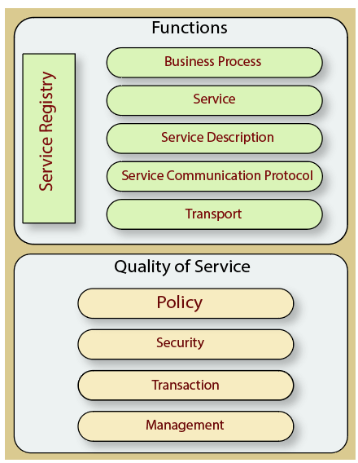

**Functional aspects**

The functional aspect contains:

* Transport - It transports the service requests from the service consumer to the service provider and service responses from the service provider to the service consumer.
* Service Communication Protocol - It allows the service provider and the service consumer to communicate with each other.
* Service Description - It describes the service and data required to invoke it.
* Service - It is an actual service.
* Business Process - It represents the group of services called in a particular sequence associated with the particular rules to meet the business requirements.
* Service Registry - It contains the description of data which is used by service providers to publish their services.

**Quality of Service aspects**

The quality of service aspects contains:

* Policy - It represents the set of protocols according to which a service provider make and provide the services to consumers.
* Security - It represents the set of protocols required for identification and authorization.
* Transaction - It provides the surety of consistent result. This means, if we use the group of services to complete a business function, either all must complete or none of the complete.
* Management - It defines the set of attributes used to manage the services.

Advantages of SOA

SOA has the following advantages:

* Easy to integrate - In a service-oriented architecture, the integration is a service specification that provides implementation transparency.
* Manage Complexity - Due to service specification, the complexities get isolated, and integration becomes more manageable.
* Platform Independence - The services are platform-independent as they can communicate with other applications through a common language.
* Loose coupling - It facilitates to implement services without impacting other applications or services.
* Parallel Development - As SOA follows layer-based architecture, it provides parallel development.
* Available - The SOA services are easily available to any requester.
* Reliable - As services are small in size, it is easier to test and debug them.

The service is a kind of operation which is well defined, self contained that performs a specific task.

## Entity Service

The entity services include entities of customer such as purchase order, insurance policy, invoice of order, ordered date etc in which you can perform CRUD operations such as Create, Read, Delete and Update on the entities. These services provide information of the business process stored in the databases and handle the business entities.

## Task Service

The task service adds the business logic to other services and due to its focus on business entity, it contains low amount of reusability. Task services provide operations on more than one entity such as customer purchase order, creating purchase order number, validating customer details etc. **A service is called as task service when it needs to access the multiple entities.**

## Utility Service

The utility services are technology oriented services which are used to build larger and higher level services and provides other capabilities which are unrelated to the message transfer. **The utility services provide reusable functions such as event logging, creating unique number and notification etc to the other functional domains**. These services contain small, closely packed services which are used as building blocks in service oriented system.

## Proxy Service

The proxy services contain the services which act as connection between members of the service oriented system and conflict subsystem. The device and process services lie under this type of services. Sometimes services which are defined under proxy services are called as gateway services.

## Device Service

The device service is a kind of proxy service which is **referred as hardware device and used to communicate between other services.** The device service does not include the API which is not well suited with the service oriented system.

## Process Service

The device service is also a kind of proxy service which acts as **interpreter between application and service oriented system members.** This service creates and arranges the application services to implement the business processes.

## Business Service

Business services are also known as controller service which provides business functions for the completion of the business process and are flexible services that changes the business needs. These services develop the business applications that automate the **business process such as managing the customer service, shipping the customer product etc.**